

**ANL201**

**Data Visualisation for Business**

**End-of-Course Assessment**

**Jul 2024**

|  |  |
| --- | --- |
| Name | B HARIPPRIYA |
| PI Number | K2170295 |
| T-Group | T04 |
| Date Submitted | 01/11/2024 |

**Question 1**

|  |  |  |  |  |  |  |  |  |
| --- | --- | --- | --- | --- | --- | --- | --- | --- |
| **Data Field** | **Data Type & Justification** | **Summary Statistics** | | | | | | |
| Mean | Median | Mode | Min | Max | Standard Deviation | No. of Observation |
| Cust_ID | Nominal. The values are for identification purposes and do not provide any real meaning. | NA | NA | NA | NA | NA | NA | 15566 |
| num_passengers | Ratio. The values have true zero point. If value is 0, it means that there are no passengers on the flight. | 1.75 | 1 | 1 | 1 | 9 | 1.16 | 15582 |
| sales_channel | Nominal. The values represent categories and do not have any meaningful order. | NA | NA | Internet | NA | NA | NA | 15582 |
| trip_type | Nominal. The values represent categories and do not have any meaningful order. | NA | NA | RoundTrip | NA | NA | NA | 15582 |
| purchase_lead | Ratio. The values have true zero point. If value is 0, it means the passenger is booking a flight on the same day he is departing from. | 87.67 | 51 | 2 | -206 | 867 | 95.29 | 15582 |
| length_of_stay | Ratio. The values have true zero point. If value is 0, it means that the passenger is arriving to and departing from destination on same day. | 12.41 | 6 | 6 | 1 | 778 | 24.49 | 15582 |
| flight_hour | Interval. Numbers do not have true zero point. If value is 0, it does not mean that there’s an absence of time. | 9.19 | 9 | 13 | 0 | 26 | 5.32 | 15582 |
| flight_day | Ordinal. These values represent categories and they have a meaningful order. | NA | NA | Mon | NA | NA | NA | 15582 |
| booking_origin | Nominal. The values represent categories and they have no meaningful order. | NA | NA | Malaysia | NA | NA | NA | 15582 |
| wants_extra_baggage | Nominal. The values represent categories and they have no meaningful order. | NA | NA | 1 | NA | NA | NA | 15582 |
| wants_preferred_seat | Nominal. The values represent categories and do not have any meaningful order. | NA | NA | 0 | NA | NA | NA | 15582 |
| wants_in_flight_meals | Nominal. The values represent categories and do not have any meaningful order. | NA | NA | 0 | NA | NA | NA | 15582 |
| flight_duration | Ratio. The values have true zero point. If value is 0, it means that flight did not take off. | 6.90 | 6.62 | 8.83 | 4.67 | 20 | 1.50 | 15582 |
| booking_complete | Nominal. The values represent categories and do not have any meaningful order. | NA | NA | 0 | NA | NA | NA | 15582 |

**Question 2**

**Quality issue 1**:

16 Missing values in Cust_ID column (*Figure 1*). Since the IDs are in chronological order (*Figure 2*), missing cells can be filled using “=IF(A47<>"", MAX(A$2:A47) + 1, "")” which adds 1 to the max of preceding cells (*Figure 3*). *Figure 4* and *5* shows the filled cells.

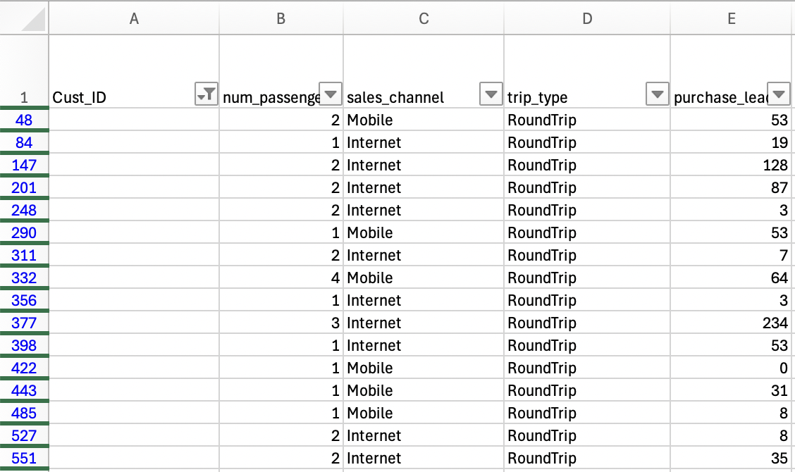 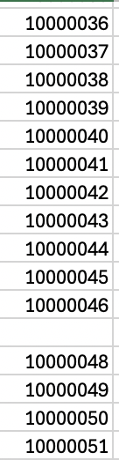

*Figure 1: Missing values in Cust_ID column Figure 2: ID in chronological order*

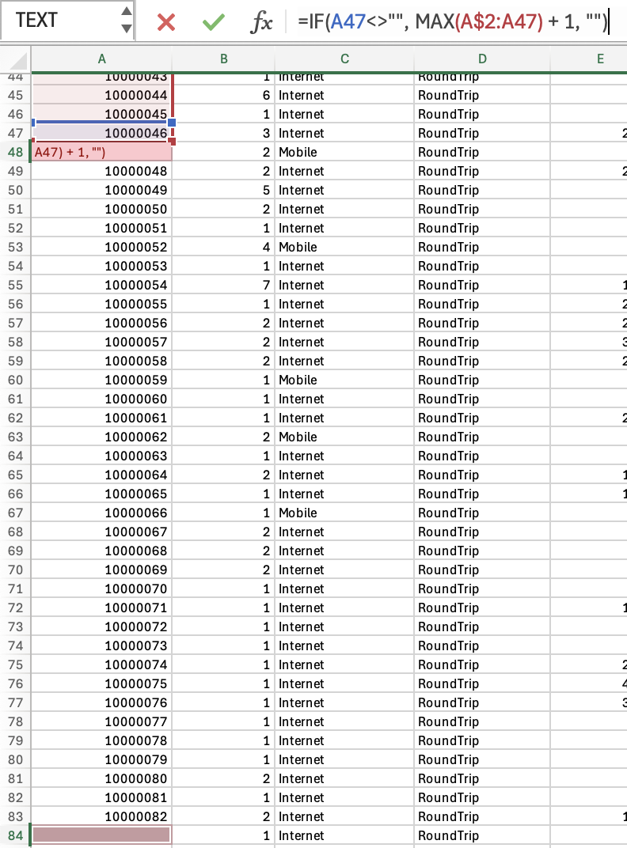 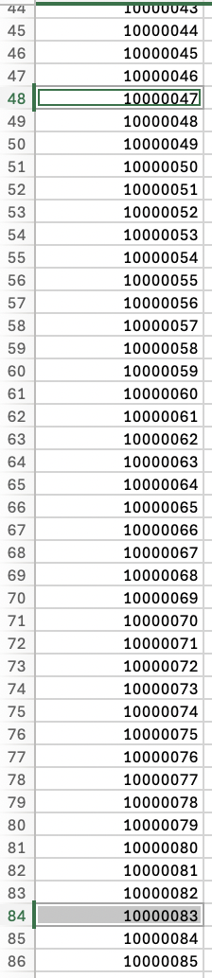

*Figure 3: formula to fill missing values Figure 4: missing values filled.*

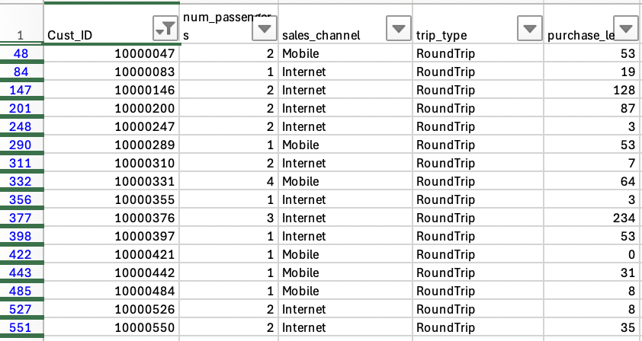 *Figure 5: Missing cells filled using formula.*

**Quality Issue 2**:

4 records has negative values in purchase_lead column (*Figure 6*). This indicates that the booking date has passed the travel date and it can be assumed that its an invalid booking. The appropriate treatment is to remove the records (*Figure 7*).



*Figure 6: Records with negative values in purchase_lead column*

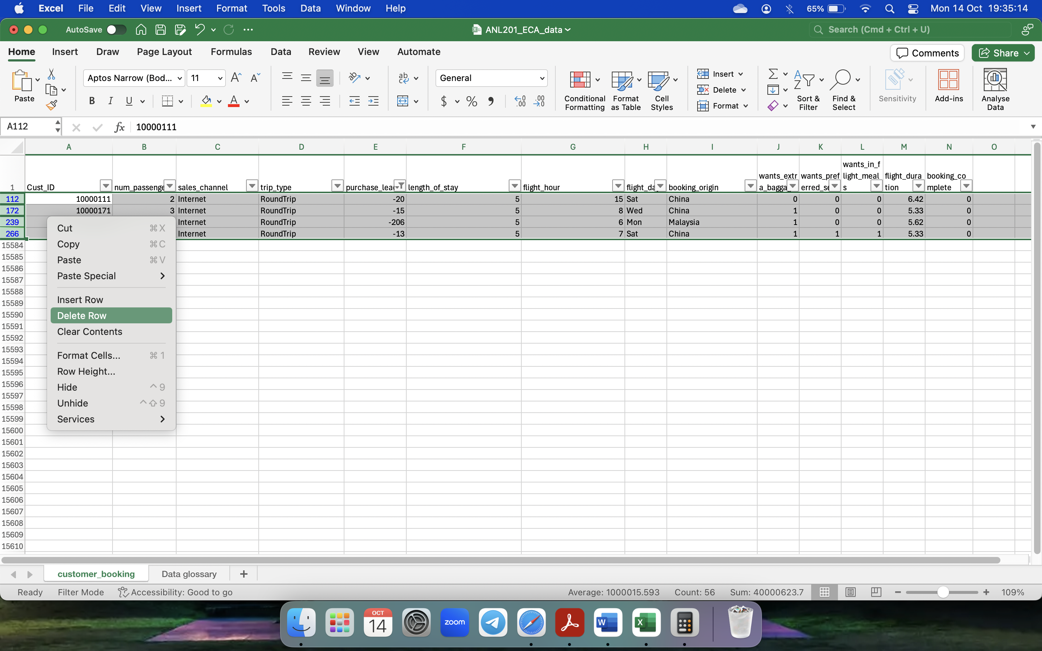

*Figure 7: Delete records with negative values in purchase_lead column*

**Quality Issue 3**:

2 records has decimal values in length_of_stay column (*Figure 8*). It can be assumed that passenger is staying the full day since most accommodations conduct checkout at 12pm. Therefore, the values should be rounded up to the nearest whole number using ROUNDUP formula (*Figures 9 and 10*). Final output shown in *Figure 11*.



*Figure 8: Records with decimal points in length_of_stay column*

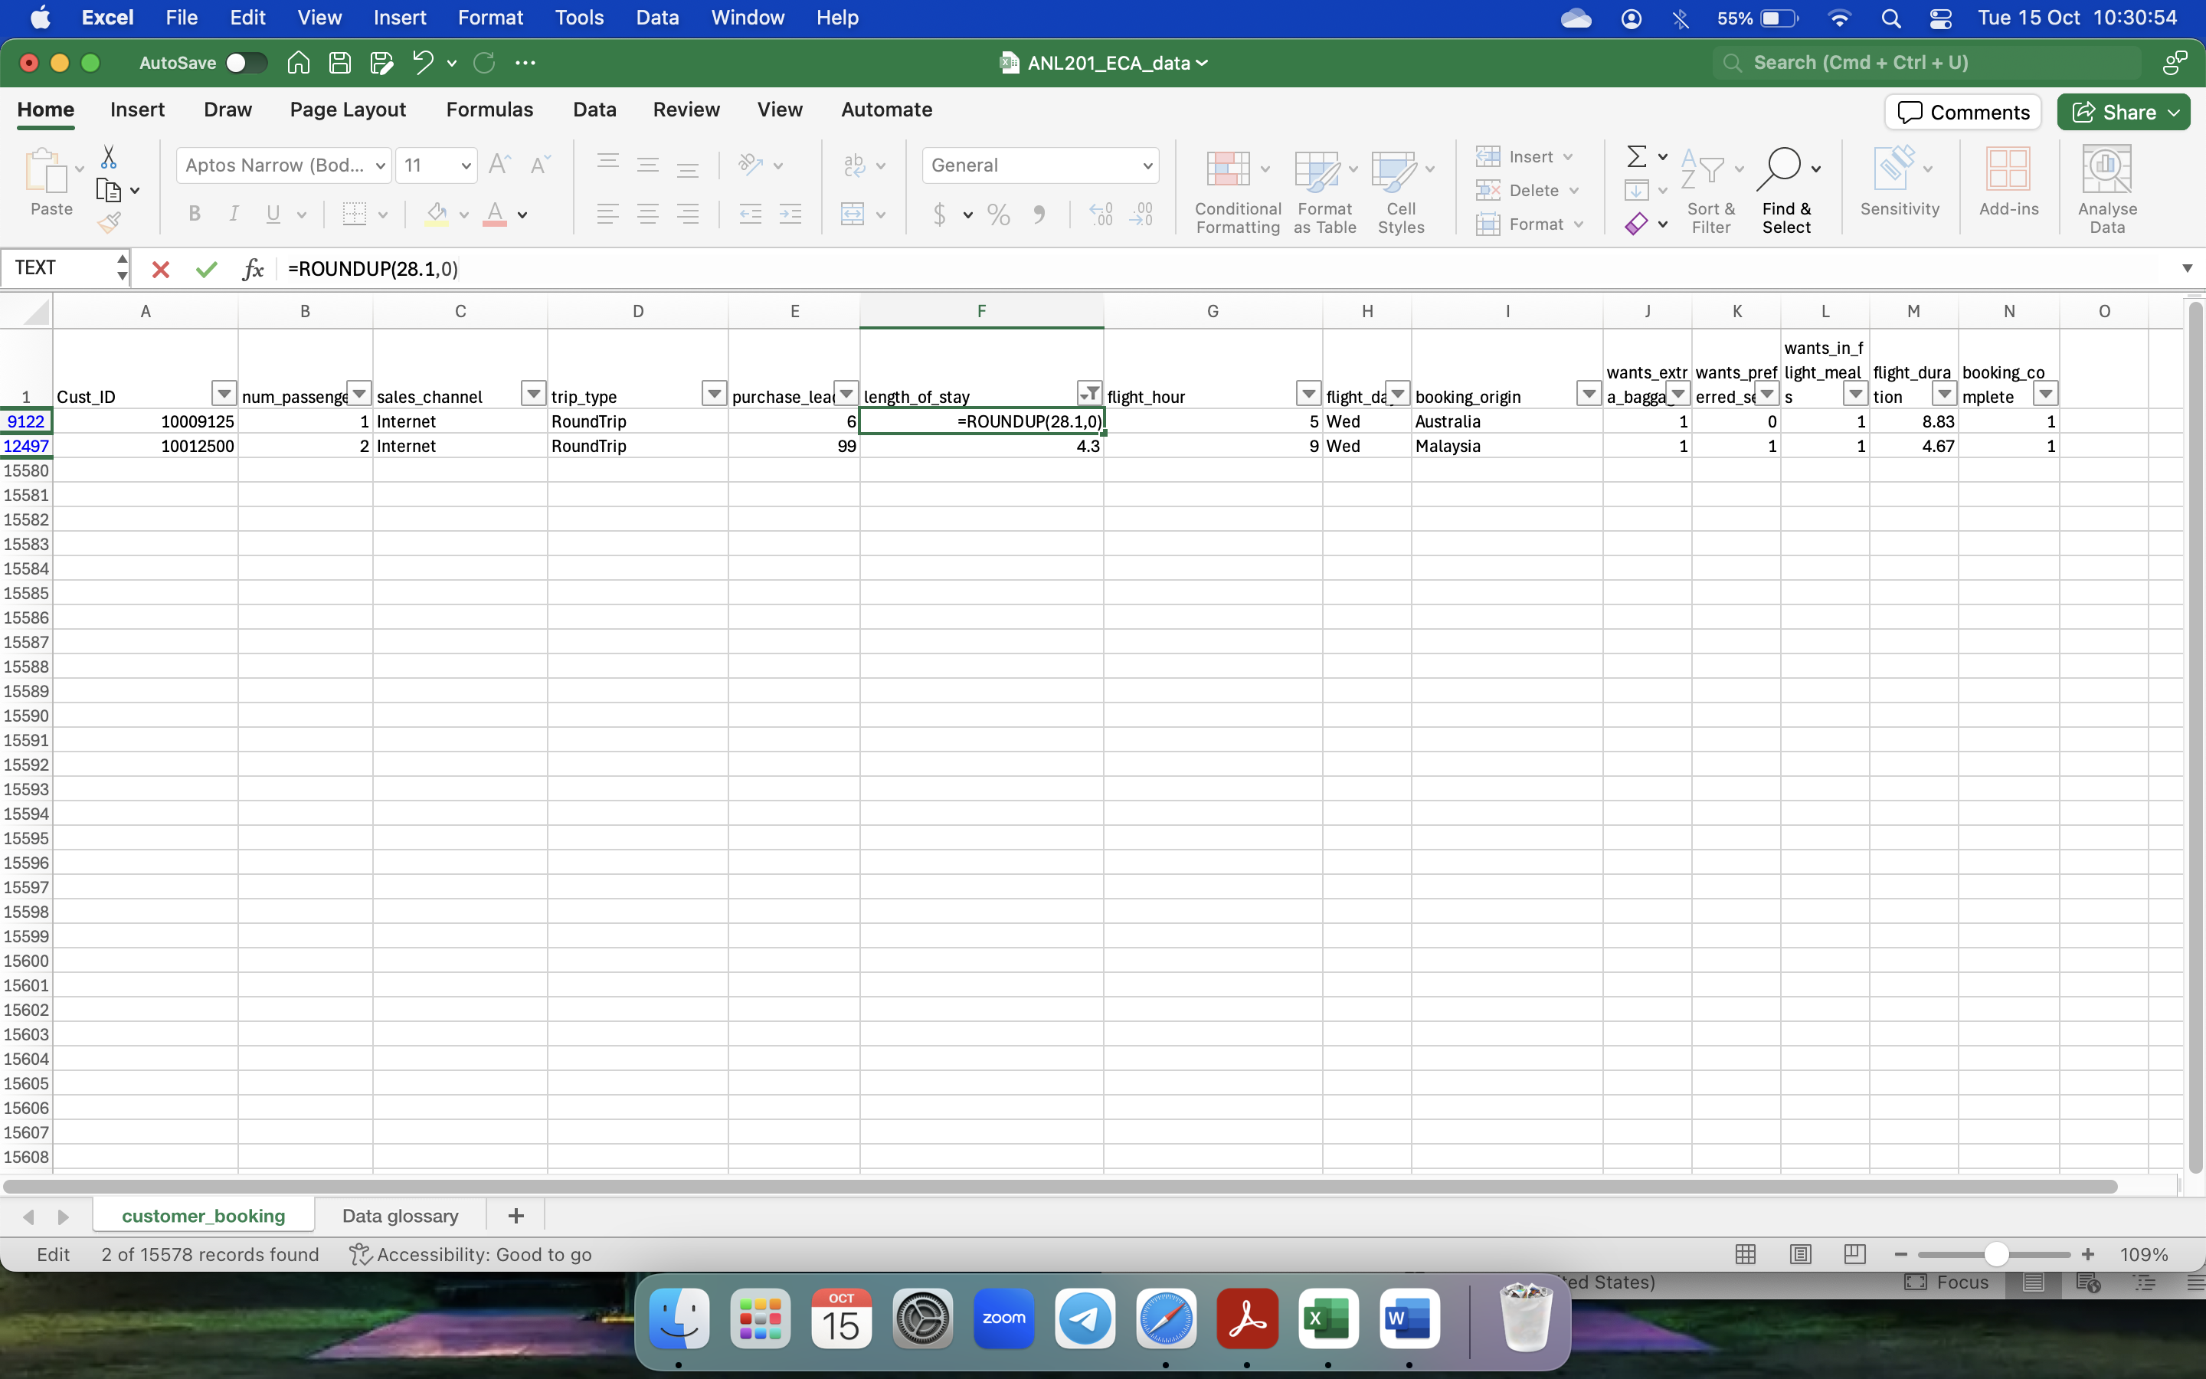

*Figure 9: Record rounded up using ROUNDUP formula*

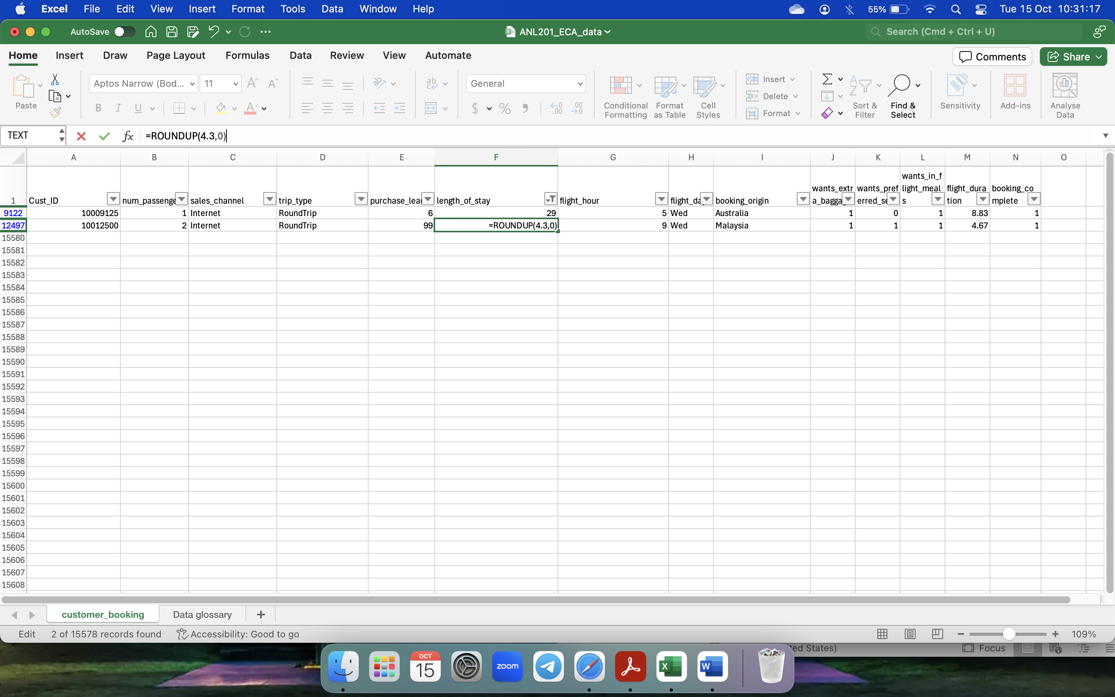

*Figure 10: Record rounded up using ROUNDUP formula*



*Figure 11: Records after being rounded up*

**Quality Issue 4**:

1 record has “26” in flight_hour column (*Figure 12*). This could be an outlier as the hours in a day are from “0” to “24”. Since only a single record is affected, it can be removed (*Figure 13*).

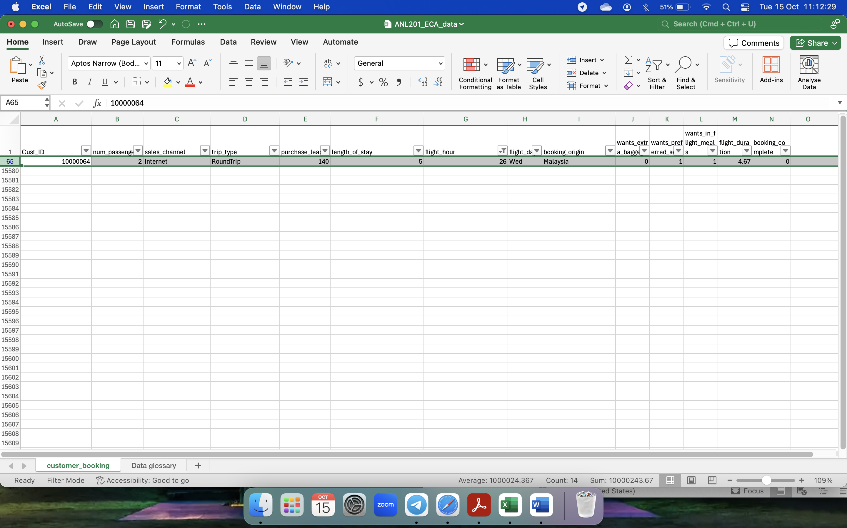

*Figure 12: Record with “26” in flight_hour*

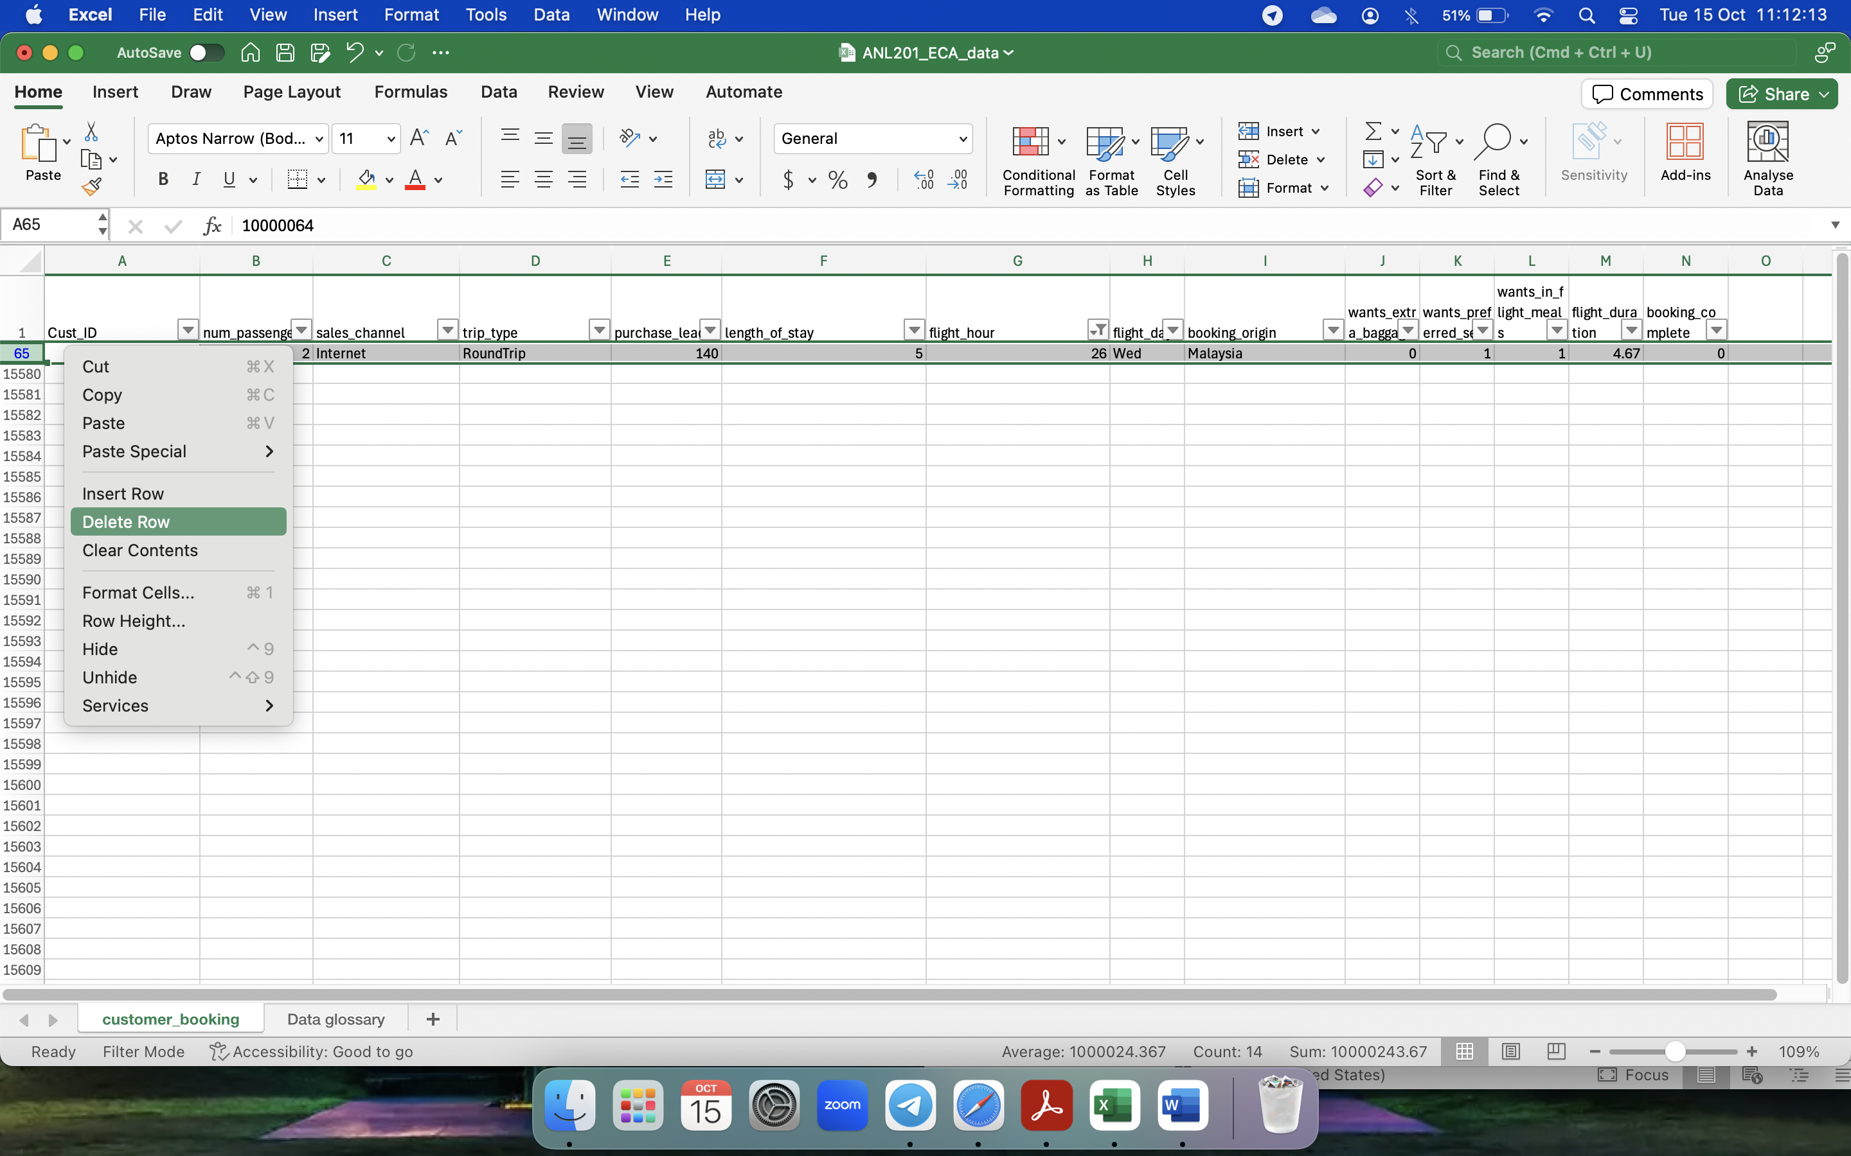

*Figure 13: Record being deleted*

**Quality Issue 5**:

31 records have “not set” values in booking_origin column (*Figure 14*). The appropriate treatment is to replace the values with the mode of the column which is “Malaysia” using Find and Replace function (*Figure 15*). *Figure 16* shows the records after the values are replaced.

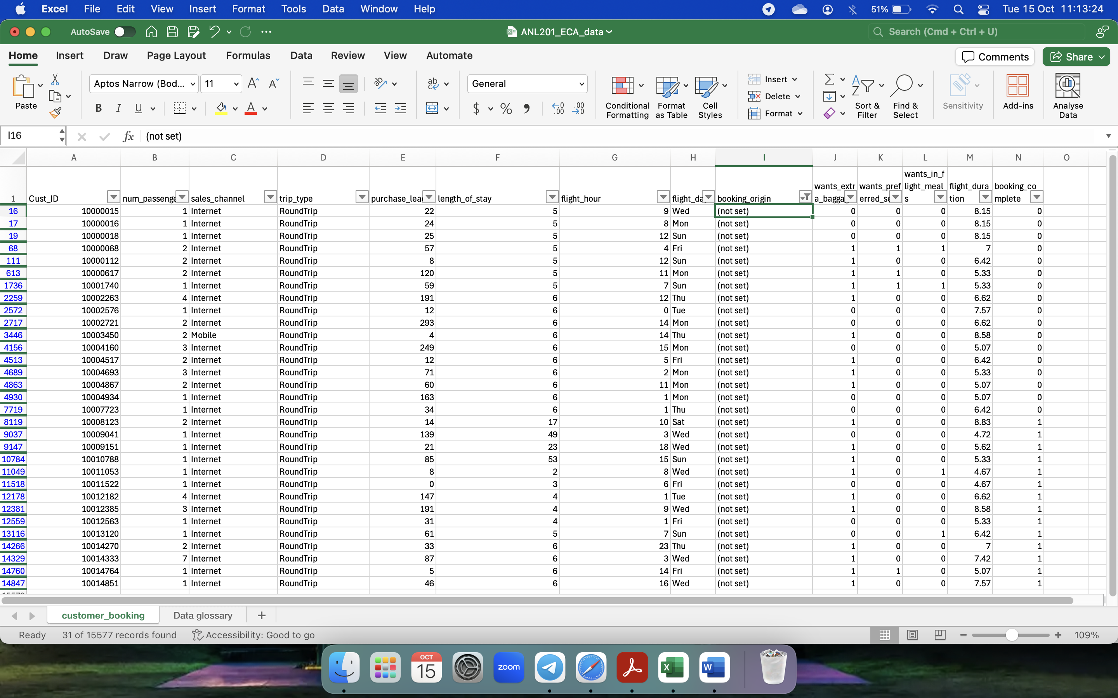

*Figure 14: Records with “not set” value*

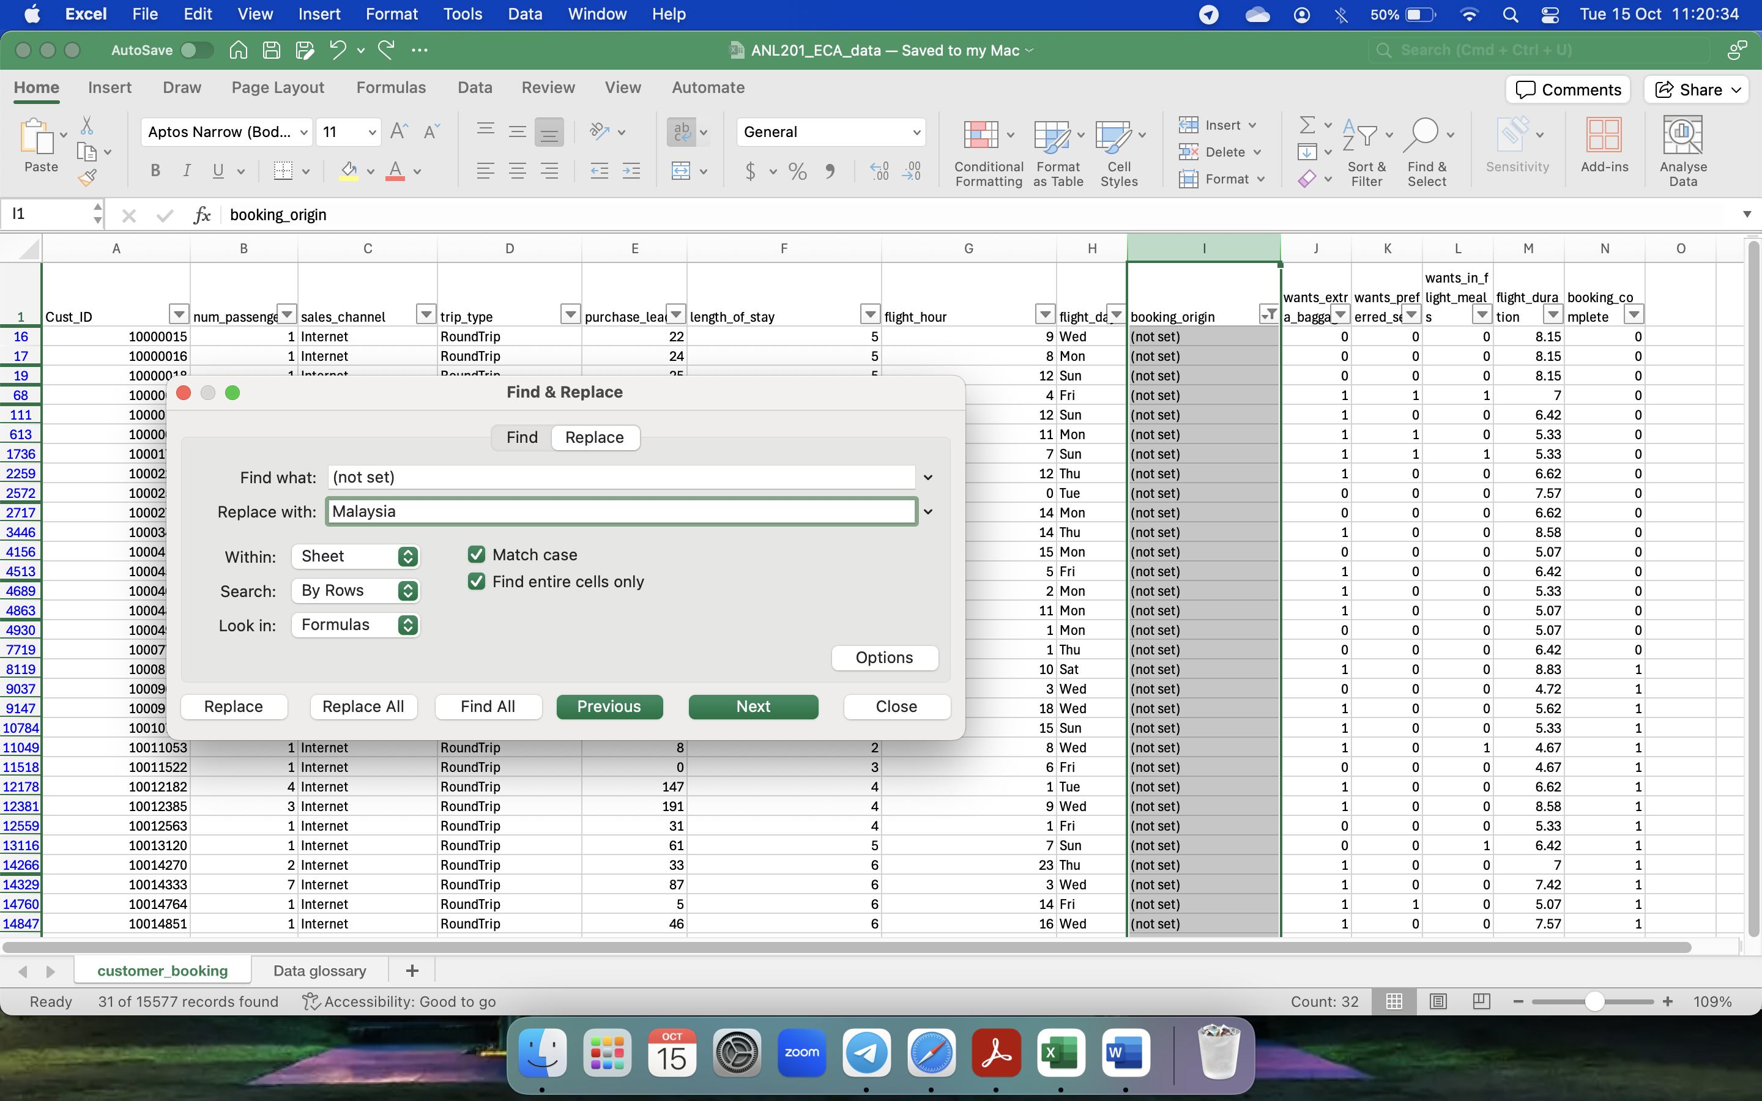

*Figure 15: Values being replaced*

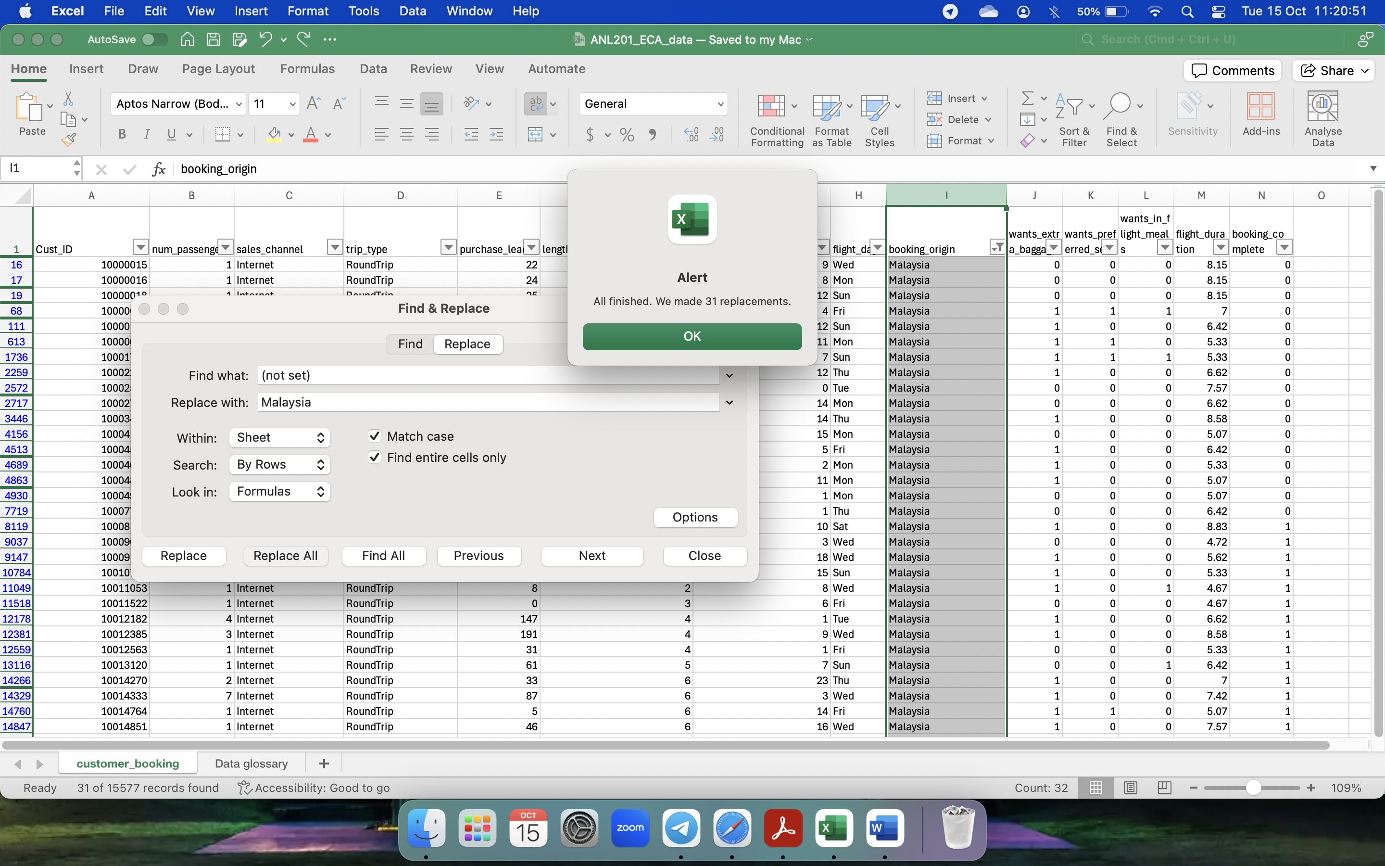

*Figure 16: Records after Values replaced*

**Word Count: 239 words excluding words under figures**

**Question 3**

The first chart created is a line graph showing passenger traffic by day and flight hour using a parameter and a reference line to show weekly average traffic per hour for completed bookings (*Figure 17*). In this example, for Flight hour 12, the average is 105 with Monday generating the highest and Saturday generating the lowest traffic. It is revealed that Wednesday is preferred day and Friday to Sunday are least preferred days for travel overall. Hour 6,9,13,14 are popular for flying.

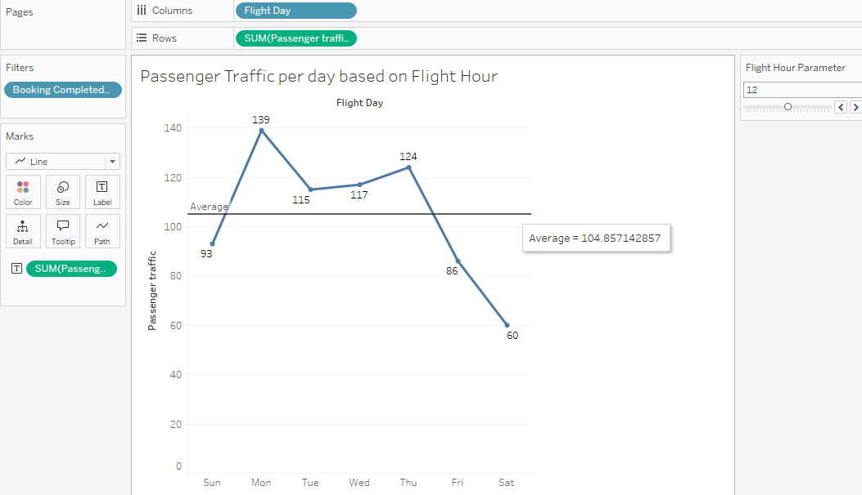

*Figure 17: Line graph showcasing passenger traffic per day based on Flight Hour*

The second chart uses a stacked bar chart to show the Frequency of extra services needed based on Flight Hour with calculated fields to determine the sum of extra baggage, In flight meal and preferred seat for completed bookings (*Figure 18*). It can be seen that extra baggage is more popular over other addons. Flight Hours 6 – 14 generally has more passengers willing to choose the extra addons provided.

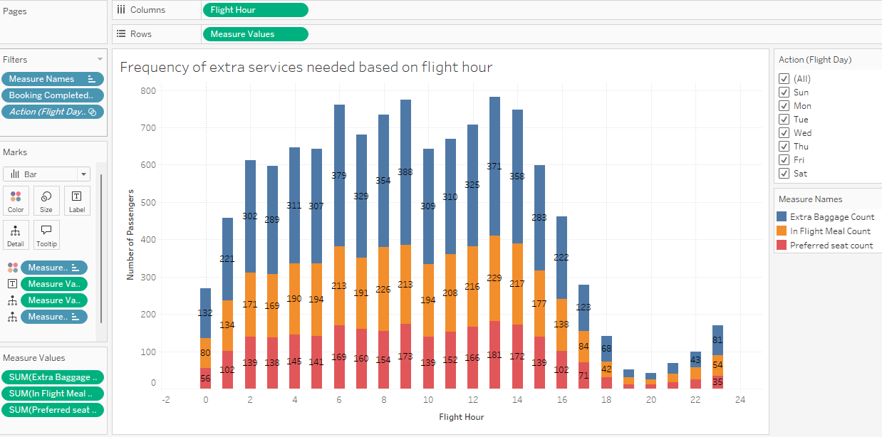

*Figure 18: Frequency of extra services needed based on flight hour*

The third chart created showcases the number of completed bookings made across different countries for completed bookings using a map chart (*Figure 19*). From the chart below, Asian and Australian continents have higher customers flying out.

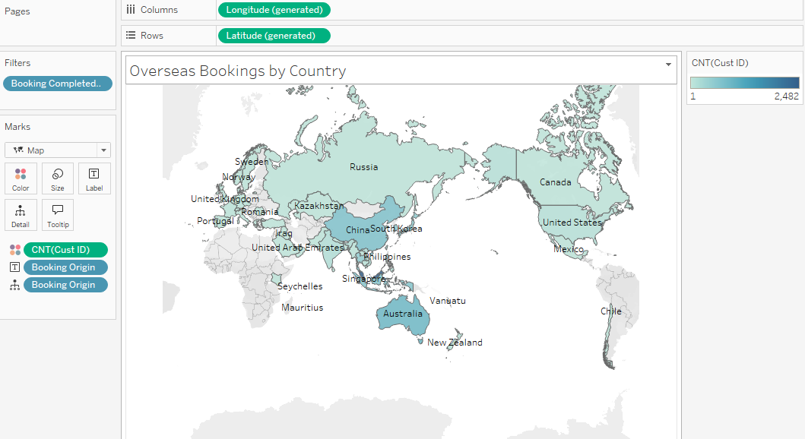

*Figure 19: Overseas Bookings by Country*

The fourth chart created is to find the correlation between purchase lead and length of stay based on Trip type for completed bookings using a scatter plot (*Figure 20*) below. CircleTrip is generally booked well in advance as compared to RoundTrip but the length of stay is longer in RoundTrip than CircleTrip. Oneway trips are booked closer to the travel date and passengers have a short stay.

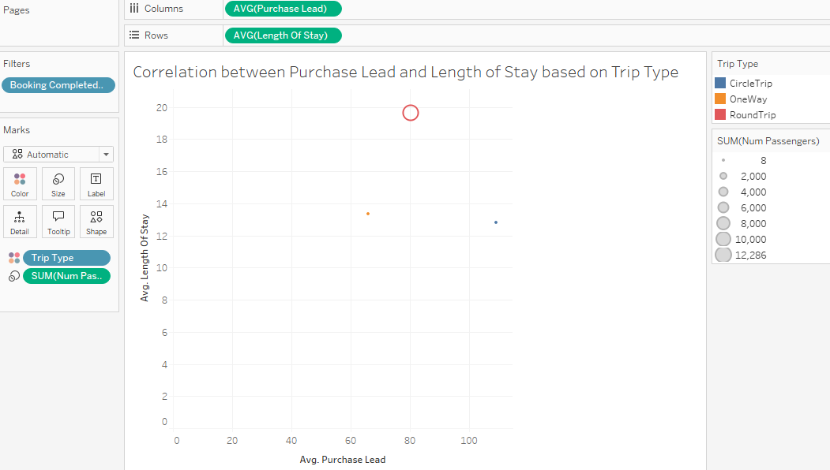

*Figure 20: Correlation between Purchase Lead and Length of Stay based on Trip Type*

**Word Count: 254 words excluding words under figures**

**Question 4**

*Figure 21* below shows the business performance dashboard titled “Understanding Passenger Behaviours”. The purpose of this dashboard is to analyze the passenger’s behaviours in terms of purchase patterns, service preferences and passenger traffic so that insights gathered can be used to come up with new marketing strategies.

The dashboard below caters to the dashboard design principles because there is a simple and effective layout without too much of formatting being done. The charts pertaining to Flight Hour are kept at the bottom together for easy visualization. The labels at the side are arranged in sequence according to the respective charts and each chart is clear to see.

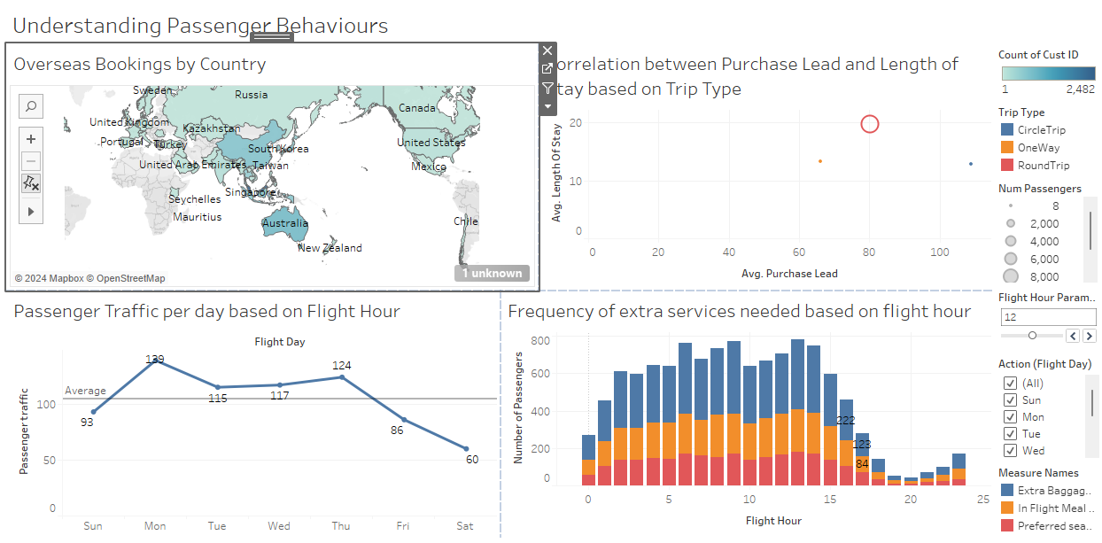

*Figure 21: Business performance dashboard*

There are 2 actions being set up to allow audience to drill down and find more insights. The 2 actions are navigating to an external URL and filtering.

The first action is navigating to an external URL. *Figure 22* below shows the settings to create a URL that navigates to the Wikipedia page of a specific country selected in the map chart. *Figure 23* shows that when the country is selected, the URL will appear and *Figure 24* shows that when the URL is selected, the Wikipedia page will be shown.

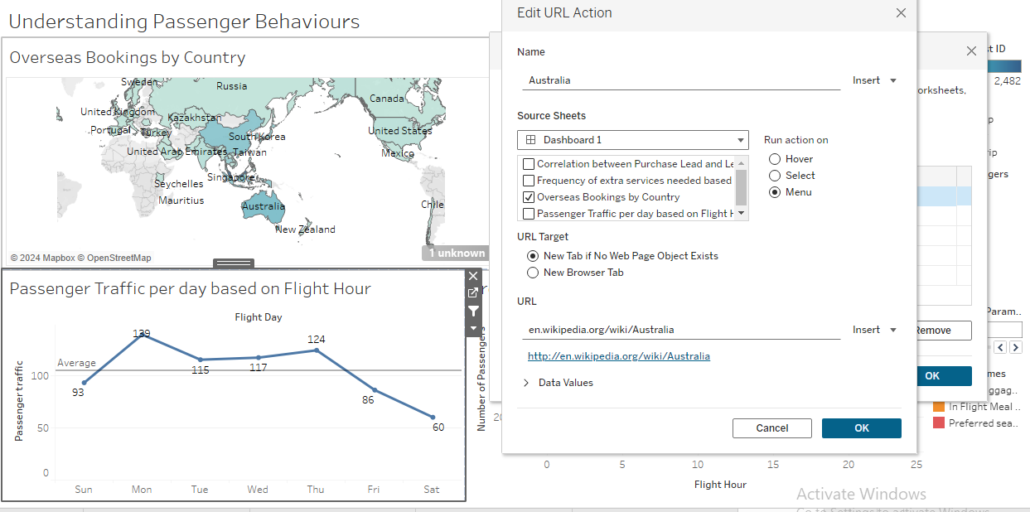

*Figure 22: Action settings for creating URL*

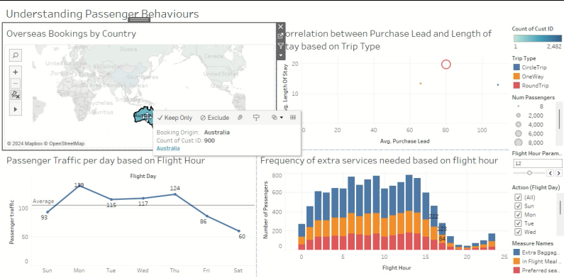

*Figure 23: URL displayed when clicking on country*

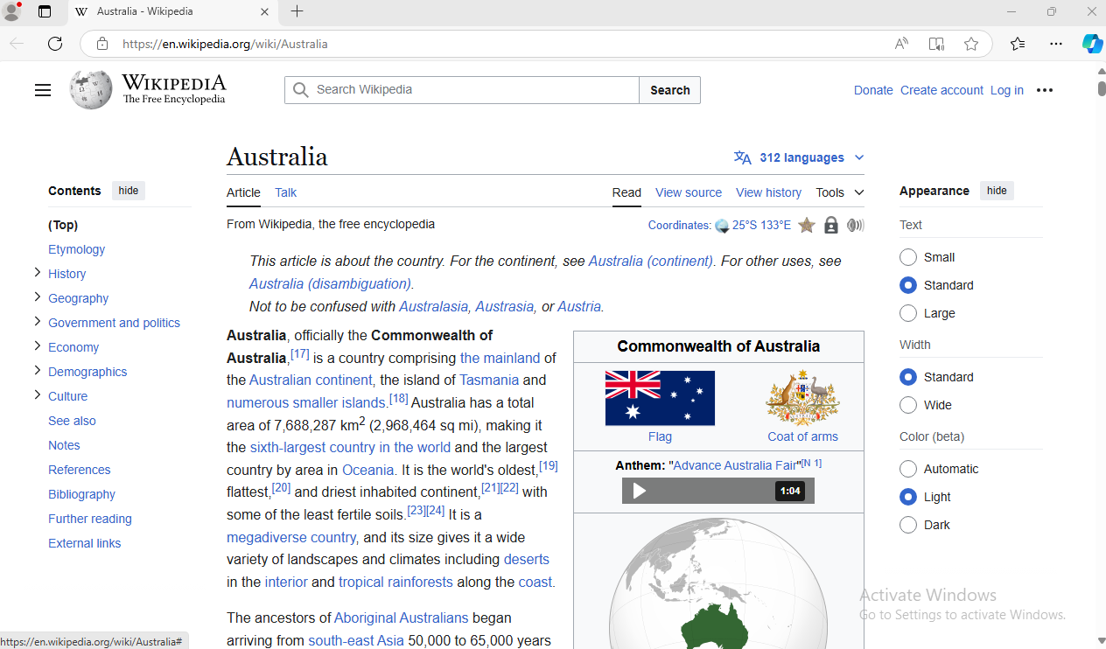

*Figure 24: Wikipedia page displayed after URL is clicked on*

The second action is to filter out the total number of passengers requesting for each addon based on a flight hour for that day. *Figure 25* shows the settings to create the action. *Figure 26* shows that when the value for Thursday is selected on the Line chart, the stacked bar chart beside it displays the request of the addons by passenger for Thursday for all Flight Hours.

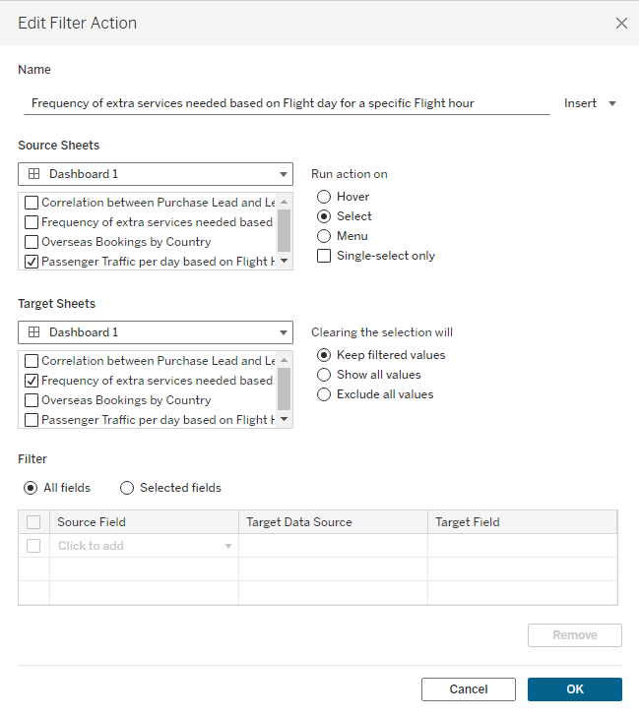

*Figure 25: Settings of action*

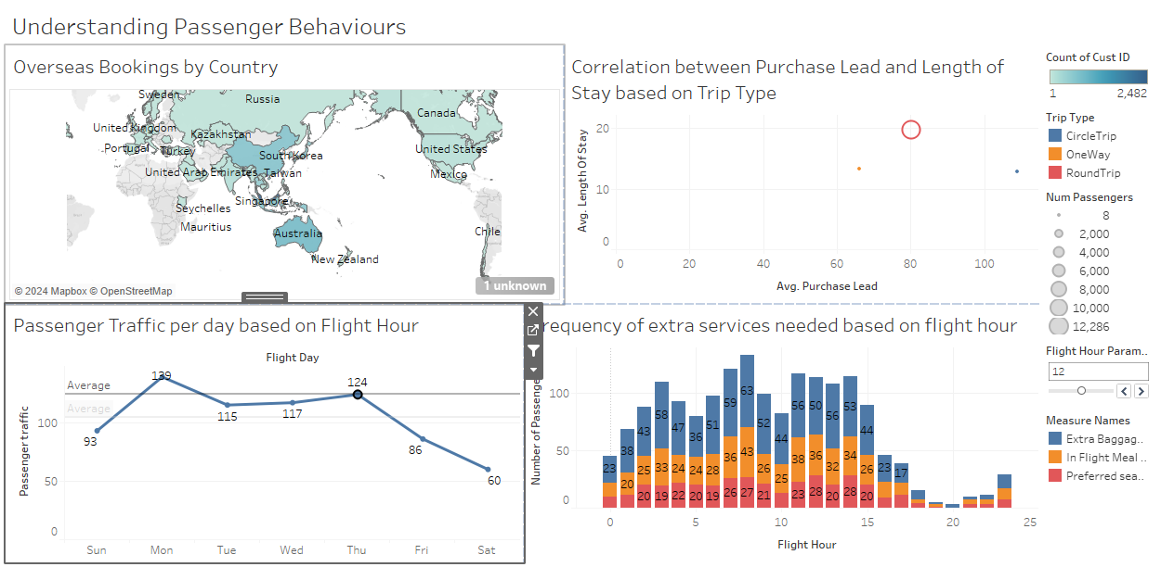

*Figure 26: value ‘124’ under Thursday is selected in line chart and corresponding addon frequencies are displayed in the stacked bar chart*

**Word Count: 266 words excluding words under figures**